**Cricket Kit Contribution - Requirement 1**

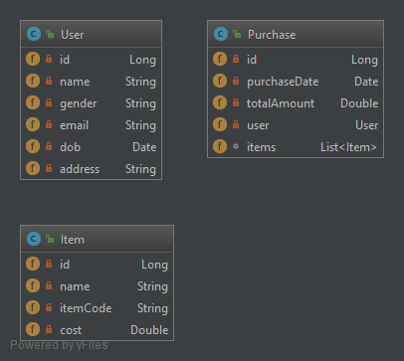

You are an aspiring cricket player and have joined your city team. The City cricket council is heavily underfund and proper training equipments are not available for the players for nourishing their talent. You along with your teammates decide to contribute in purchasing training kits and other required things for effective practice sessions. Some senior players are responsible for purchasing sports utilities from the given funds according to the needs. They wish to keep track of the items purchased and the funds spent and collected. You decide to build a small application to help them out.

**Requirement 1:**

Let’s start off by creating an item class based on the below mentioned specifications.

1. Create an Item Class with the following attributes:

|  |  |
| --- | --- |
| **Member Field Name** | **Type** |
| id | Long |
| name | String |
| itemCode | String |
| cost | Double |

1. Mark all the attributes as private
2. Create / Generate appropriate Getters & Setters
3. Add a default constructor and a parameterized constructor to take in all attributes in the given order: Item(Long id, String name, String itemCode, Double cost)
4. When the “item” object is printed, it should display the following details: [Override the toString method]  
   Print format:  
   **String.format("%-5s %-15s %-15s %s", "ID","Name","Item Code","Cost");**
5. Two items are considered same if they have the same name and item code. Implement the logic in the appropriate function. (Case – Insensitive) [Override the equals method]  
   The input format  consists of item details seperated by comma in the below order,  
   (**id,name,itemCode,cost**)

The Input to your program would be details of two items, you need to display their details as given in "5th point(refer above)" and compare the two items and display if the items are same or different.  
  
**Note:**There is an empty line between display statements  
  
**Sample INPUT & OUTPUT 1:**  
  
Enter item 1 detail:  
**1,Cake,ITM001,50.0**  
Enter item 2 detail:  
**2,Bread,ITM002,30.0**  
  
Item 1:  
ID    Name            Item Code       Cost  
1      Cake              ITM001             50.0  
  
Item 2:  
ID    Name            Item Code       Cost  
2     Bread           ITM002          30.0  
  
Item 1 and Item 2 are different  
  
**Sample INPUT & OUTPUT 2:**  
  
Enter item 1 detail:  
**1,Computer,ITM001,15000.0**  
Enter item 2 detail:  
**2,computer,ITM001,18000.0**  
  
Item 1:  
ID    Name            Item Code       Cost  
1     Computer        ITM001          15000.0  
  
Item 2:  
ID    Name            Item Code       Cost  
2     computer        ITM001          18000.0  
  
Item 1 is same as Item 2